ABOUT VIEWPOINTS
Viewpoints is a JISC-funded curriculum design project which aims to help teams/teachers create innovative, learner-centred course designs.
HOW IT WORKS?
The Viewpoints project has created themed workshops and reflective resources to inform, inspire and help practitioners plan effective curriculum designs. Workshops are focused around four main areas: assessment and feedback, information skills, learner engagement and creativity and innovation. Each theme is underpinned by well-established pedagogical approaches.
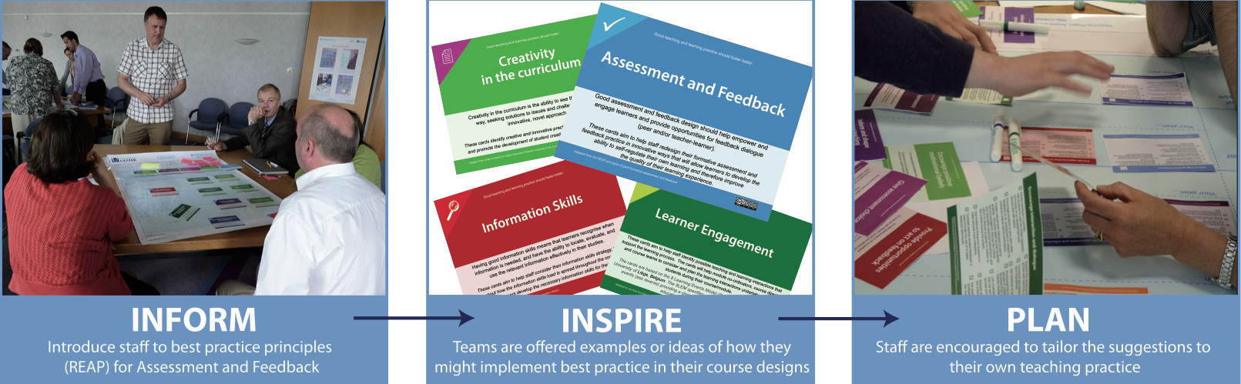
They provide a series of simple, user-friendly reflective tools/prompts that promote a creative and effective approach to the curriculum design process and help teams/teachers think about important stages for their students at different points on the learner timeline.
WORKSHOP BENEFITS
“The Viewpoints workshop process offers an innovative and successful way to engage course teams in meaningful dialogue about curriculum design”. (David Nicol, 2012).

“The workshops are short and sweet (1-2 hours) and use best practice resources to help practitioners reflect on and develop their curricula. Information is organised into topics and issues and actions recorded on a large laminate sheet”. (UG-Flex Project, Greenwich).

“I think you come out of the Viewpoints workshop with a different perspective, a different way of thinking. I think it leads to greater openness amongst the course team – the cards encourage that sort of open discussion and willingness to share and change....This continues after the workshop.” (Viewpoints Participant).

“The potential to use this in my institution is great – it helps the dialogue about designing the curriculum” (Viewpoints External Participant).
FURTHER INFORMATION
Viewpoints project: http://viewpoints.ulster.ac.uk
Viewpoints resources: http://wiki.ulster.ac.uk/display/VPR/Home
Dr Alan Masson  Project Director  aj.masson@ulster.ac.uk | Catherine O’Donnell  Academic E-Learning Consultant  c.odonnell@ulster.ac.uk | Dr Vilinda Ross  Research Fellow  v.ross@ulster.ac.uk

